ASSIGNMENT – 04
Software-Defined Networking (SDN)

1. Aim
To configure a Software-Defined Networking (SDN) environment using Mininet, Open vSwitch, and the Ryu Controller, and demonstrate basic network forwarding and traffic filtering.

2. Software Requirements
- Ubuntu 26.04
- Mininet
- Open vSwitch
- Python 3
- Ryu SDN Controller
- Oracle VirtualBox

3. Procedure
Step 1: Update Ubuntu
Command:
sudo apt update && sudo apt upgrade -y
Updates the Ubuntu system and its installed packages.
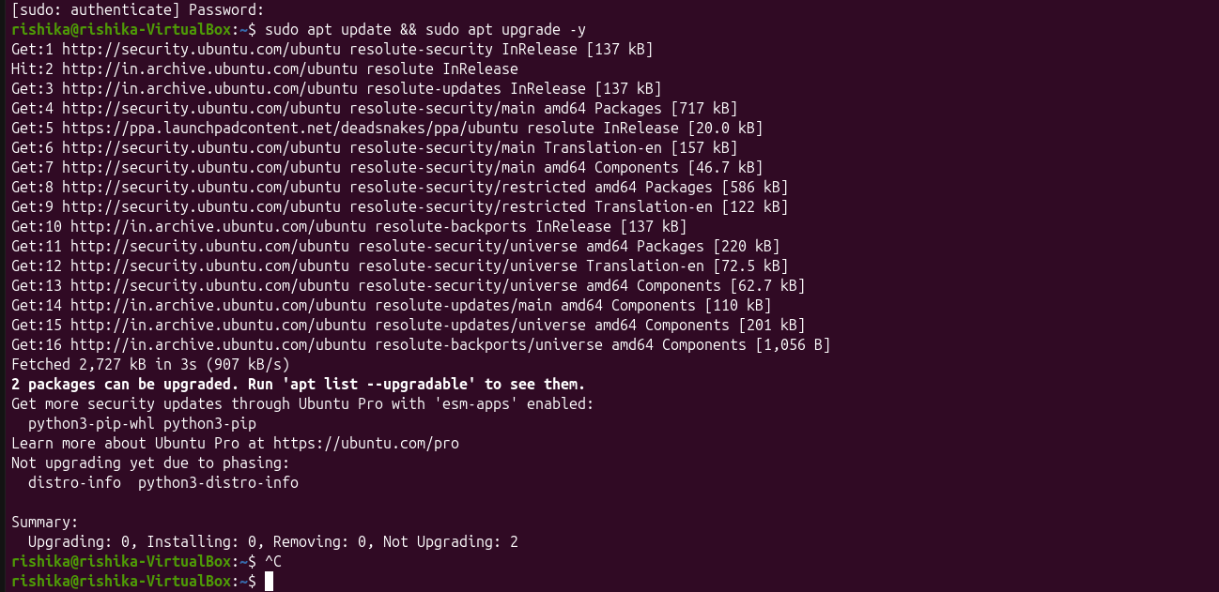

Step 2: Install Mininet
Command:
sudo apt install mininet -y
Installs Mininet to create and simulate virtual networks.
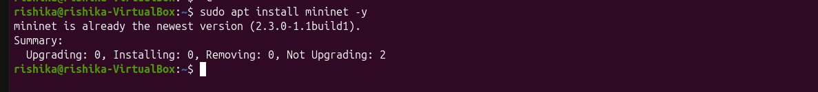
Step 3: Install Open vSwitch
Command:
sudo apt install openvswitch-switch -y
Installs Open vSwitch, which acts as the software-based SDN switch.
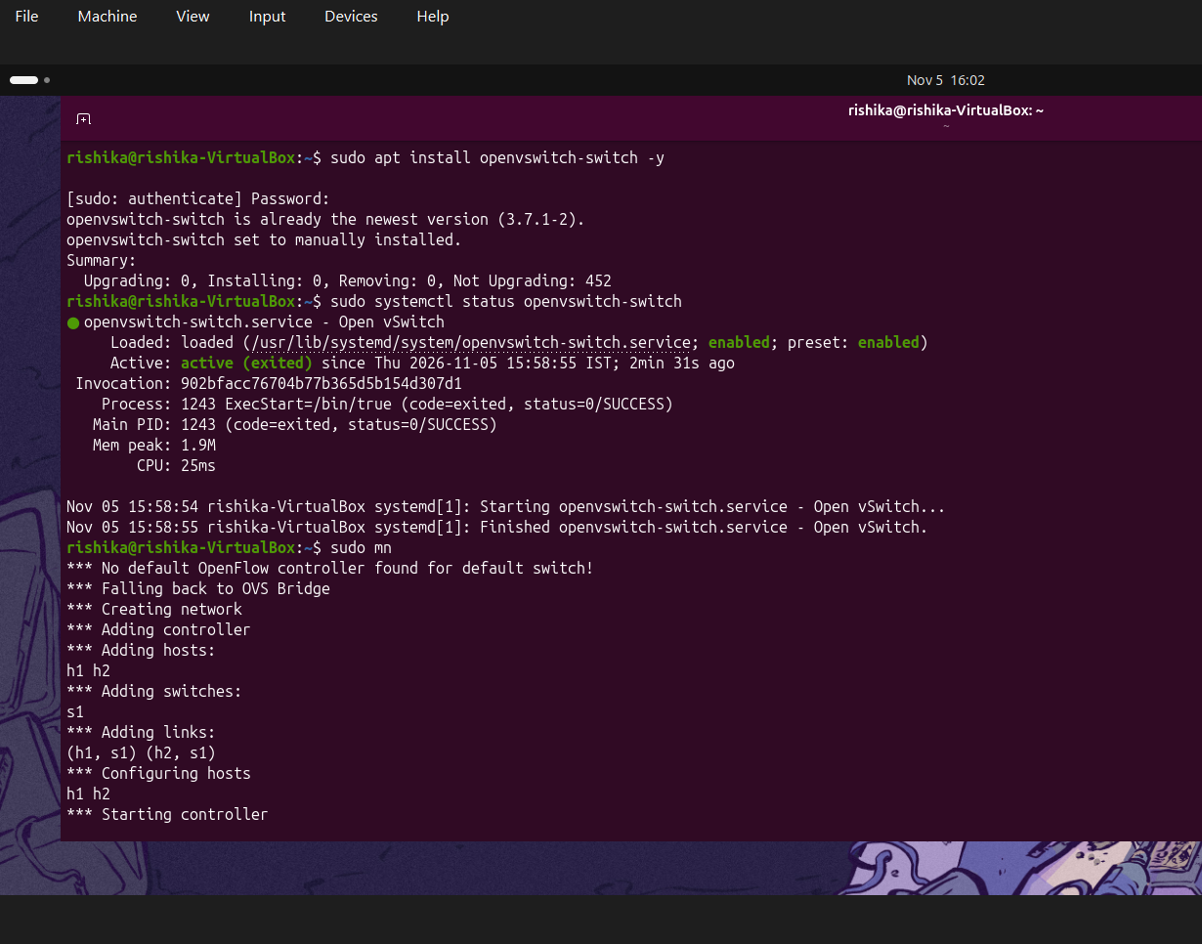
Step 4: Check Open vSwitch
Command:
sudo systemctl status openvswitch-switch
Checks whether the Open vSwitch service is running.
Step 5: Test Mininet
Commands:
sudo mn
mininet> nodes
mininet> pingall
mininet> exit
Starts Mininet, displays the available network nodes, tests connectivity, and exits the environment.
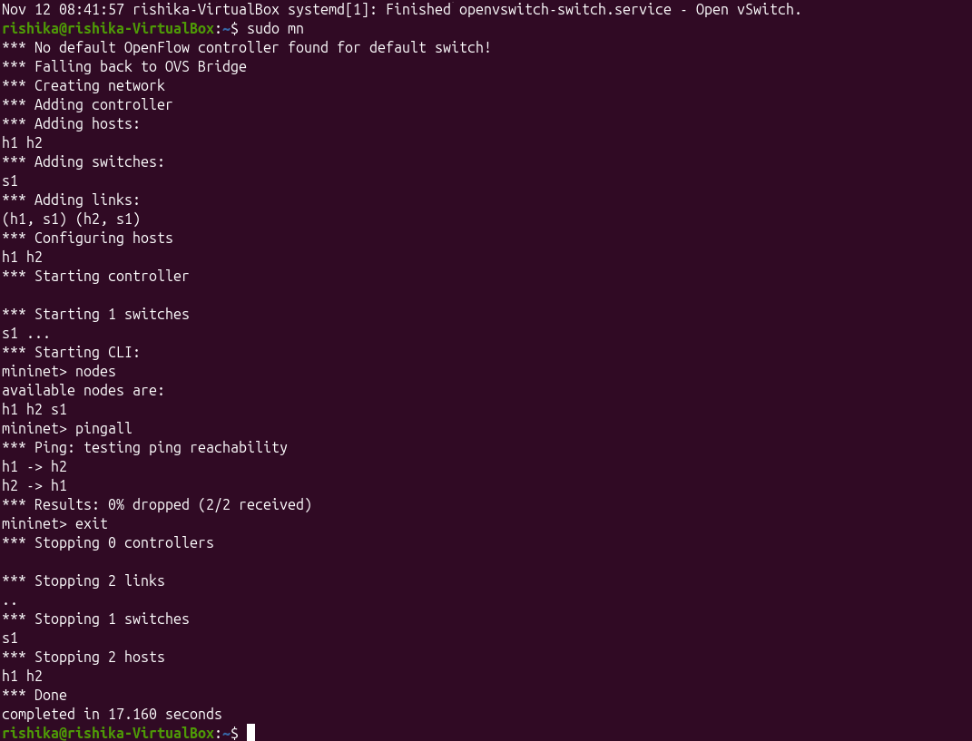
Step 6: Install Python and Virtual Environment
Command:
sudo apt install python3-pip python3-venv -y
Installs Python package management and virtual environment support.
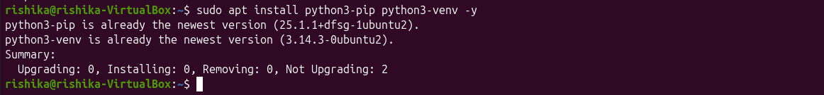
Step 7: Create Ryu Environment
Commands:
python3 -m venv ryu-env
source ryu-env/bin/activate
Creates and activates a separate Python environment for installing Ryu.
Step 8: Install Ryu
Command:
pip install ryu
Installs the Ryu SDN Controller and its required dependencies.

Step 9: Test Ryu Installation
Command:
ryu-manager --version
Displays the installed version of the Ryu Controller.
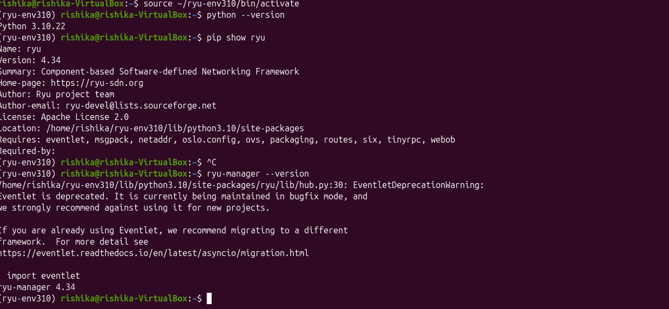

Step 10: Start Ryu Controller
Command:
ryu-manager ryu.app.simple_switch_13
Starts the Ryu Controller with the Simple Switch application using OpenFlow 1.3.
Keep this terminal running.
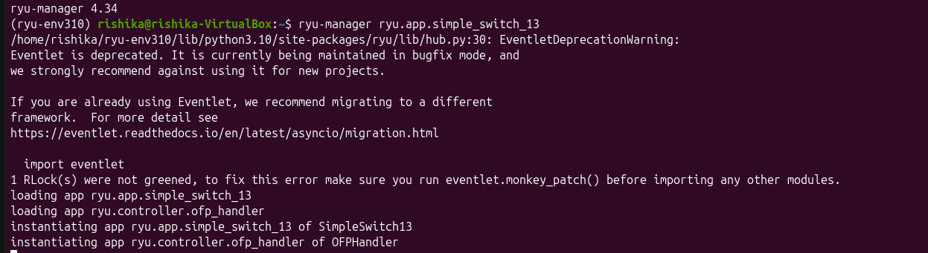
Step 11: Create Mininet SDN Topology
Open a new terminal and execute:
sudo mn --topo single,3 --controller=remote --switch ovsk
Creates a network with three hosts connected to one Open vSwitch and the remote Ryu Controller.

Step 12: Check Network Nodes
Command:
mininet> nodes
Displays the three hosts (H1, H2, H3) and the switch (S1).

Step 13: Check Network Connections
Command:
mininet> net
Displays the connections between the hosts and the switch.

Step 14: Test Network Connectivity
Commands:
mininet> pingall
mininet> h1 ping h2
Tests communication between all hosts and checks connectivity between H1 and H2.
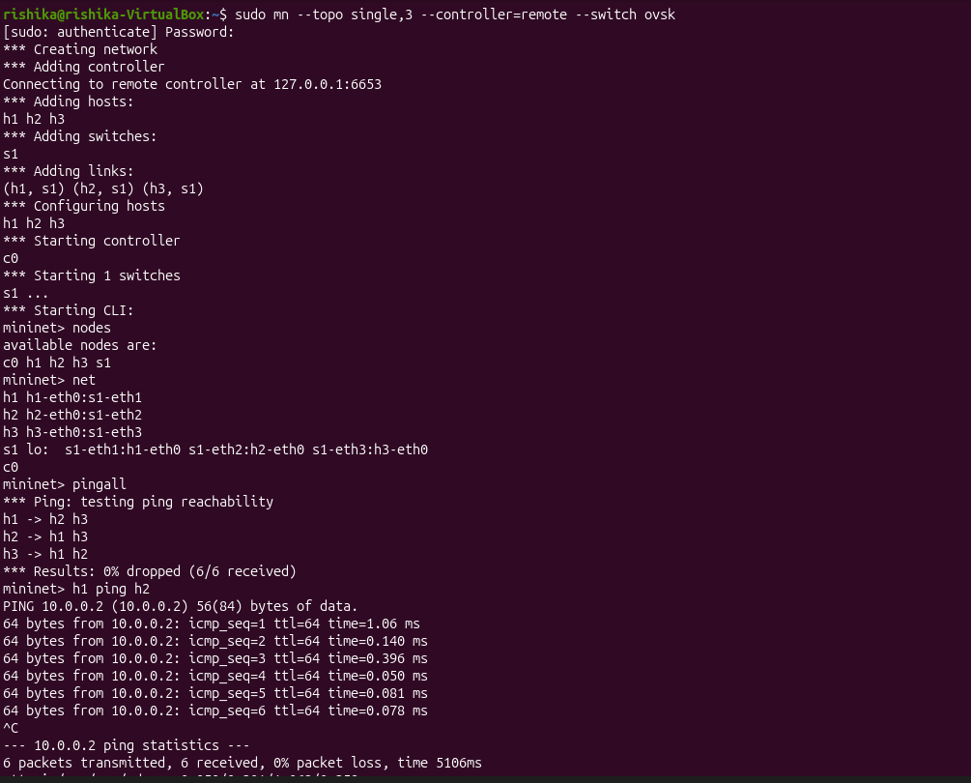
Step 15: View Flow Rules
Open another terminal and execute:
sudo ovs-ofctl -O OpenFlow13 dump-flows s1
Displays the flow rules installed in the Open vSwitch.
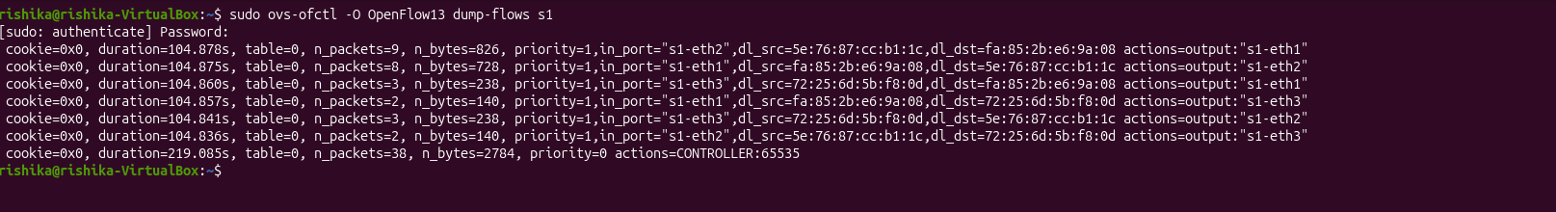
Step 16: Add a Simple Filtering Rule
Command:
sudo ovs-ofctl -O OpenFlow13 add-flow s1 "priority=100,in_port=1,actions=drop"
Adds a filtering rule that drops packets entering the switch through port 1.
Step 16: Add a Simple Filtering Rule
Command:
sudo ovs-ofctl -O OpenFlow13 add-flow s1
"priority=100,in_port=1,actions=drop"
Adds a filtering rule that drops packets entering the switch through port 1.
Step 17: Test the Filtering Rule
Command:
mininet> h1 ping h2
Tests the effect of the filtering rule by checking whether H1 can communicate with H2.
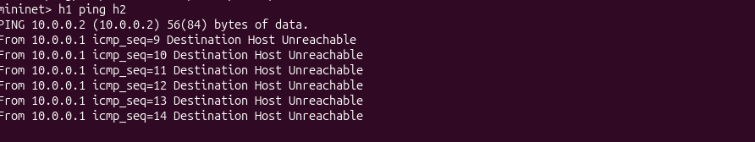
Step 18: Remove Flow Rules
Command:
sudo ovs-ofctl -O OpenFlow13 del-flows s1
Attempts to remove the manually added flow rule from the switch.

Step 19: Clean Mininet
Command:
sudo mn -c
Cleans up Mininet interfaces, processes, and network configurations.


